Johnson & Johnson Company Analysis
Name:
Tutor:
Institution:

Introduction
Johnson & Johnson Company commonly termed as J&J in short form, is a well-known popular company in the world. It was founded in 1887 as a holding company. Its headquarters is based in New Jersey in the United States of America. The company is among the listed companies in Fortunate 500. It has around 116,000 workers in 60 different countries. It is known for producing and selling human well-being related products and it is the most known diversified health company. Robert Johnson was the first president to the company and upon his death, the position was taken by James Johnson who was his brother. The current president of J&J Company is William Weldon.
Today, J&J have more than 200 companies around the world that specialize in pharmaceuticals, diagnosis, medical devices and operating products. is actually the leading company in drug-coated industry. The brands of the company includes; Tylenol, Listerine, Visine, Splenda, Neutrogena and Band Aid. The company is considered successful for its strong management practices which are usually decentralized. The employees are proud to be part of the company and no one wishes to get fired. The company also manufactures and sells care skin products such as skin care, child care and baby care.
Johnson & Johnson Company’s business models, are divided in three segments; Medical devices $ Diagnosis, Pharmaceutical and Consumer. However, J&J Company focuses more on providing Pharmaceutical products.

Johnson & Johnson Company and primary competitors
The main competitors of J&J company as at 2018, includes; Pfizer Inc., Novartis, Roche, Procter & Gamble Co., Abbvie Inc, Gilead Sciencies Inc and Merck & Co. Inc. the following chart shows the performance in sales in 2017.
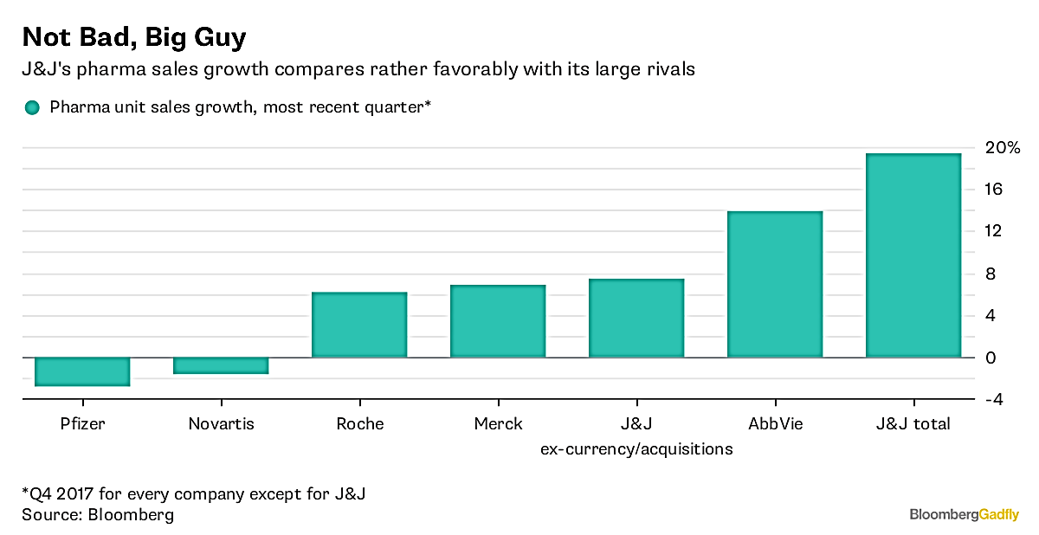
From the graph, among its peers, AbbVie seem to haven taken the leading position, J&J Company, takes the second lead, Merck takes the third position, Novartis follows and Pfizer as the least in health care industry. J&J Company may have been experiencing different economic trends but still manages to lead over other competitive companies due to their pricing uniqueness, sales promotion programs, persuasive advertisements, and increased efficiency in product technique and product innovation. Additionally, it occasionally introduce new packaging, dispensing equipment, new vending, trade mark protection and brand development through sponsorships.
Economic Issues That Represent Threats or Opportunities
There is an economic crisis in Johnson & Johnson Company since private companies have taken lead providing health services and especially nursing services. Due to declines consumption disposable income, there have been huge impacts to countries that prominently use health insurance models in payments. Due to the increased pressure from health shareholders, the industry is consolidated through acquisitions and mergers.

Threats
J&J faces a stiff competition which adds pressure on the price of its goods. In return, this fluctuate the currency which later becomes a threat to J&J Company. Despite the company having a strong portfolio, the segment growth is around 0.5% which is much attributed by the increased pressure in prices. The currency issue poses a risk on the global market that the sales of J&J have reduces by 2% due to currency instability. If this strong competition continues to rise, the J&J Company are in the risk of losing their patent of having the best selling drugs. Additionally, there have been some technological developments in bio-products which seem to take the lead and are finally going to replace the pharmaceutical products in the market.
Opportunities
However, J&J Company has the capability to grow since its brand is diversified and it provides range of products. Also, by putting more focuses on advanced technology and innovation, the company can develop even more quality products for the consumers. Moreover, J&J Company can even increase its network through mergers and acquisitions with other companies providing pharmaceutical products. For instance, in 2006, the company was boosted by acquiring the ownership over customer health of Pfizer. It also observed to have improved the quality of its products after a breakthrough in their research in cancer therapy in 2016.
FINANCIAL ANALYSIS
Annual financial statements for the past five years
According to the annual financial analysis, the net sales seem to decrease from $ 74.33 Billion in 2014 to $ 70.07 Billion in 2018. This has been along with a decrease in the cost of the products. As a result, this decreases their gross profit continuously along the years. In 2014, the gross profit was $51.59 Billion while in 2018; the gross profit was $54.49 Billion. As shown in the financial statement below;
Fiscal year is Jan - Dec | 2018 | 2017 | 2016 | 2015 | 2014
Johnson & Johnson Revenues or Net Sales | 81.58B | 76.45B | 71.89B | 70.07B | 74.33B
Cost Of Goods Sold (COGS) | 27.09B | 25.35B | 21.69B | 21.54B | 22.75B
Johnson & Johnson Gross Profit | 54.49B | 51.1B | 50.21B | 48.54B | 51.59B
Research & Development Expense | 11.9B | 10.96B | 9.12B | 9.27B | 8.67B
Selling General & Admin Expense | 24.81B | 22.3B | 21.29B | 19.78B | 21.95B
Income Before Depreciation Depletion Amortization | 16.78B | 16.9B | 19.07B | 18.94B | 20.43B
Depreciation Depletion Amortization | - | - | - | - | -
Non Operating Income | - | - | - | - | -
Interest Expense | 1.01B | 934M | 726M | 552M | 533M
Johnson & Johnson Pretax Income | 18B | 17.67B | 19.8B | 19.2B | 20.56B
Provision for Income Taxes | 2.7B | 16.37B | 3.26B | 3.79B | 4.24B
MinorityInterest | - | - | - | - | -
Investment Gains Losses | - | - | - | - | -
Other Income | - | - | - | - | -
Income Before Extraordinaries & Disc Operations | 15.3B | 1.3B | 16.54B | 15.41B | 16.32B
Extraordinary Items & Discontinued Operations | - | - | - | - | -
Johnson & Johnson Profit/ Loss (Net Income) | 15.3B | 1.3B | 16.54B | 15.41B | 16.32B
Average Shares used to compute Diluted EPS | 2.73B | 2.75B | 2.79B | 2.81B | 2.86B
Average Shares used to compute Basic EPS | 2.73B | 2.75B | 2.79B | 2.81B | 2.86B
Income Before Nonrecurring Items | 22.32B | 20.04B | 18.76B | 17.45B | 17.11B
Income from Nonrecurring Items | -7.02B | -18.74B | -2.22B | -2.04B | -782M
Johnson & Johnson Earnings Per Share Basic Net | 5.61 | 0.47 | 5.93 | 5.48 | 5.70
Johnson & Johnson Earnings Per Share Diluted Net | 5.61 | 0.47 | 5.93 | 5.48 | 5.70
EPS Diluted Before Nonrecurring Items | 8.18 | 7.30 | 6.73 | 6.20 | 5.97
Preferred Dividends Acc Pd | - | - | - | - | -
Dividends Common | 9497.47 | - | - | - | -
Dividend Per Share Common | 3.54 | 3.32 | 3.15 | 2.95 | 2.76

Quarterly Statements for the five most recent Quarters
There is no much difference in the performance of the J&J Company in the quarterly years for it follows the same pattern as in annual performance. The increase in revenues is still increases and decreases overtime. The fourth quarter of 2017 with $20.2 Billion; it then reduces in the first quarter of 2018 with revenue of $20.01 Billion. In the second quarter of 2018, the revenues are still seen to have increased though less significantly to $20.83 Billion, in the third quarter of 2018, it reduces to $20.35 Billion and later settles at $20.39 Billion in the fourth quarter of 2018 which is an insignificant increase. As shown in the financial statement below;
Fiscal year is Jan - Dec | 2018 Q4 | 2018 Q3 | 2018 Q2 | 2018 Q1 | 2017 Q4
Johnson & Johnson Revenues or Net Sales | 20.39B | 20.35B | 20.83B | 20.01B | 20.2B
Cost Of Goods Sold (COGS) | 6.96B | 6.59B | 6.93B | 6.61B | 7.24B
Johnson & Johnson Gross Profit | 13.43B | 13.76B | 13.9B | 13.4B | 12.95B
Research & Development Expense | 3.22B | 3.63B | 2.64B | 2.4B | 4.04B
Selling General & Admin Expense | 7.23B | 5.81B | 6.29B | 5.48B | 6.25B
Income Before Depreciation Depletion Amortization | 2.73B | 4.07B | 4.72B | 5.25B | 2.39B
Depreciation Depletion Amortization | - | - | - | - | -
Non Operating Income | - | - | - | - | -
Interest Expense | 250M | 243M | 253M | 259M | 274M
Johnson & Johnson Pretax Income | 3.12B | 4.42B | 4.97B | 5.48B | 2.56B
Provision for Income Taxes | 80M | 489M | 1.02B | 1.11B | 13.27B
MinorityInterest | - | - | - | - | -
Investment Gains Losses | - | - | - | - | -
Other Income | - | - | - | - | -
Income Before Extraordinaries & Disc Operations | 3.04B | 3.93B | 3.95B | 4.37B | -10.71B
Extraordinary Items & Discontinued Operations | - | - | - | - | -
Johnson & Johnson Profit/ Loss (Net Income) | 3.04B | 3.93B | 3.95B | 4.37B | -10.71B
Average Shares used to compute Diluted EPS | 2.72B | 2.73B | 2.72B | 2.73B | 2.68B
Average Shares used to compute Basic EPS | 2.72B | 2.73B | 2.72B | 2.73B | 2.68B
Income Before Nonrecurring Items | 5.37B | 5.59B | 5.72B | 5.64B | 4.78B
Income from Nonrecurring Items | -2.33B | -1.66B | -1.76B | -1.27B | -15.49B
Johnson & Johnson Earnings Per Share Basic Net | 1.12 | 1.44 | 1.45 | 1.60 | -3.99
Johnson & Johnson Earnings Per Share Diluted Net | 1.12 | 1.44 | 1.45 | 1.60 | -3.99
EPS Diluted Before Nonrecurring Items | 1.97 | 2.05 | 2.10 | 2.06 | 1.74
Preferred Dividends Acc Pd | - | - | - | - | -
Dividends Common | 2414.61 | 2414.61 | 2414.61 | 2253.64 | 2256.68
Dividend Per Share Common | 0.90 | 0.90 | 0.90 | 0.84 | 0.84

THE FINANCIAL RATIOS
Profitability Ratios
The profitability ratios explain the effectiveness of J&J Company in terms of the returns they get on sales and investments. The measure is done through ratios such as Net profit margin, gross profit margin, operational profit margin, Earning per share, Return on shareholder’s equity, Price earnings ratio and Return on total assets. By evaluating on asset turnover, the assets didn’t respond profitably for the business for it decreases from 2014 to 2017. It however it rises in 2018 with less significant difference. On evaluation on return on equity it decreases from 22.70% in 2014 to 21.87% in 2015. It again decreases up to 25.52% in 2018. Returns on invested capital, it does respond positively from 2014 to 2018. This means, the company is unable to allocate its capital or rather use it in long term investments.
Profitability | 2014-12 | 2015-12 | 2016-12 | 2017-12 | 2018-12 | TTM
Tax Rate % | 20.62 | 19.73 | 16.48 | 92.64 | 15.01 | 15.01
Net Margin % | 21.96 | 21.99 | 23.01 | 1.70 | 18.75 | 18.75
Asset Turnover (Average) | 0.56 | 0.53 | 0.52 | 0.51 | 0.53 | 0.53
Return on Assets % | 12.38 | 11.65 | 12.05 | 0.87 | 9.86 | 9.86
Financial Leverage (Average) | 1.88 | 1.88 | 2.01 | 2.61 | 2.56 | 2.56
Return on Equity % | 22.70 | 21.87 | 23.37 | 1.99 | 25.51 | 25.51
Return on Invested Capital % | 18.47 | 17.55 | 17.86 | 1.39 | 16.90 | 16.90
Interest Coverage | 39.58 | 35.78 | 28.28 | 19.92 | 18.91 | 18.91

Efficiency Ratios
The efficiency ratios are used to describe the quality of the business operations in collecting its money from debtor and customers and how it uses this money in managing their inventories and paying of its debts. From the chart below, J&J Company has not been able to collect money from the debtors. However, it has been clearing its debt form the suppliers. This leaves the company in a bad position since there is more money coming out than getting into the business.
Efficiency | 2014-12 | 2015-12 | 2016-12 | 2017-12 | 2018-12 | TTM
Days Sales Outstanding | 55.73 | 56.56 | 56.95 | 60.13 | 61.72 | 61.72
Days Inventory | 128.87 | 137.60 | 136.31 | 121.71 | 116.97 | 116.97
Payables Period | 111.52 | 121.19 | 114.34 | 102.41 | 100.02 | 100.02
Cash Conversion Cycle | 73.08 | 72.97 | 78.92 | 79.43 | 78.67 | 78.67
Receivables Turnover | 6.55 | 6.45 | 6.41 | 6.07 | 5.91 | 5.91
Inventory Turnover | 2.83 | 2.65 | 2.68 | 3.00 | 3.12 | 3.12
Fixed Assets Turnover | 4.53 | 4.38 | 4.52 | 4.64 | 4.79 | 4.79
Asset Turnover | 0.56 | 0.53 | 0.52 | 0.51 | 0.53 | 0.53

Johnson & Johnson Company Growth Rates compared to its peers
The financial ratios of a company are used in evaluation of the company. These ratios allow a comparison to be made between industries within the industry. The growth ratios are used to measure the returns of a company that is obtained from sales and investments. This information is used to assess the future of the company. In 2018, JNJ Company leads in generating revenues. From the graph, it leads amongst all its competitors.

COMPANY NAME |  | TICKER | REV. Y / Y | REV. SEQ. | INC. Y / Y | INC. SEQ.
Johnson & Johnson | 4 Q | JNJ | 10.57 % | 4.1 % | 3.32 % | -9.46 %
Pfizer Inc | 1 Q | PFE | -1.83 % | -3.32 % | 75.43 % | -76.16 %
Procter & Gamble Co | 2 Q | PG | -0.14 % | 3.04 % | 12.46 % | -13.85 %
Abbvie Inc. | 2 Q | ABBV | 19.21 % | 4.34 % | 3.55 % | -28.75 %
Gilead Sciences Inc | 2 Q | GILD | -20.91 % | 11.01 % | -40.73 % | 18.19 %
Merck & Co., Inc. | 2 Q | MRK | 5.39 % | 4.26 % | -12.05 % | 131.58

Earnings per Share for Johnson & Johnson Company for the Next Two Fiscal Years
In 2018, the adjusted EPS is $8.20 which is a significant growth from $7.32 value from 2017. The EPS projections in the next two fiscal years (ending of 2019 and 2010), J&J forecasted that its operational adjusted EPS will get in the range of $8.50 by the end of 2019. The implied rise of adjusted EPS in 2019 is a range of 5.7%. While in 2020, the projected value was $9.08 which insinuates a percentage of 5.67%. it is also expected to improve its operational adjusted EPS in 2021 by $9.77 which will be a percentage rise of 7.62%. As shown in the graph below;

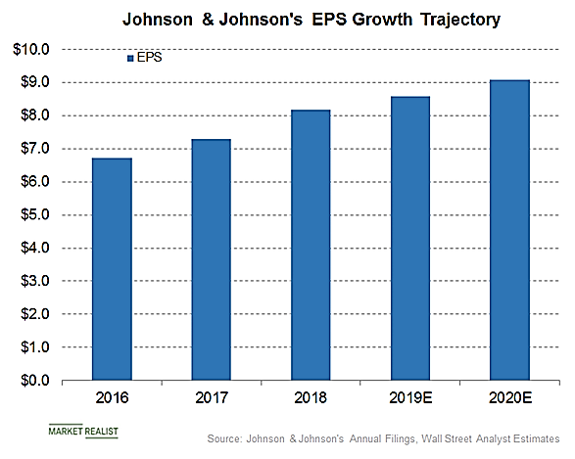

J&J Company Recommendations
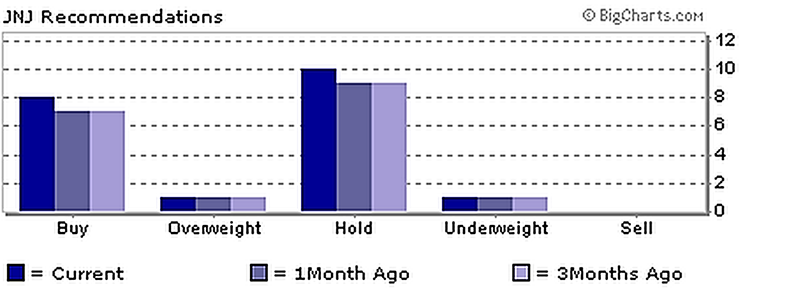
From the analysis, Johnson & Johnson Company is not a good buy currently even though it has an excellent income stock. This makes the stock very expensive and it’s likely to provide a downside. There have been very unstable economic trends, therefore, there is need to normalize the revenue growth trend. The J&J Company should hold.

References
Borkowski, S. C., Welsh, M. J., & Wentzel, K. (2010). Johnson & Johnson: A model for sustainability reporting. Strategic Finance, 92(3), 29.
Graham Hubbard, “Measuring Organizational Performance: Beyond the Triple Bottom Line,” Business Strategy and the Environment, December 2006, pp. 177-191.
Henke, R. M., Goetzel, R. Z., McHugh, J., & Isaac, F. (2011). Recent experience in health promotion at Johnson & Johnson: lower health spending, strong return on investment. Health Affairs, 30(3), 490-499.
https://amigobulls.com/stocks/T/income-statement/annual
https://financials.morningstar.com/ratios/r.html?t=JNJ
Mocciaro A., Picone P. & Minà (2012). A Bringing Strategy Back into Financial Systems of Performance Measurement: Integrating EVA and PBC, .Business System Review, Vol 1, Issue 1. Pp.85.
Turcsanyi, J., & Sisaye, S. (2013). Corporate social responsibility and its link to financial performance: Application to Johnson & Johnson, a pharmaceutical company. World Journal of Science, Technology and Sustainable Development, 10(1), 4-18.

